Current State System Architecture 2015

The current state application architecture is a highly complex integration of existing and new solutions having different platforms, hardware and software, multiple data sources with some manual, and little automated process. It provides a context for system development or enhancement. Applications areas within systems represent a useful subdivision of activities, services, and data that can be linked to other objects in the architecture. They are a group of activities and entity types with strong interdependencies such that a single application or more than one application can support the area. In the past applications communicated often via manual processes to manager large transfer of data. Files were transferred manually using ad-hoc transfer solutions, such as FTP.

Figure 4-2 shows how outputs from some systems feed into other systems via one way arrows.

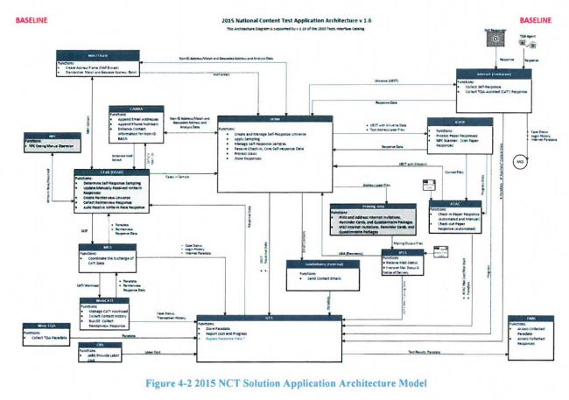

Target State System Architecture 2020

Based on a SOA paradigm where each application will provide services to the overall solution. In providing these services, these applications, can dictate development of technical enhancements and defining design patterns, APIs, Web Services, use of ESB, mobile, and cloud technologies. The ability to allow applications to use integrates enterprise data models to communicate with other systems and share data.

This modernization will consider the interoperability and interfacing elements such as data format, type, size, frequency, and performance elements such as throughput, response time, and quality of service. Future state will utilize Enterprise Integration Patterns based on API, ESB, and Managed File Transfer (MT) software to securely and efficiently share data across systems.

The target state application architecture will be a set of application areas identified to support the 2020 census. Its provides a context for system development or enhancement. Application areas represent a useful subdivision of activities, services, and data that can be linked to other objects in the architecture. There will be a group of activities and entity types with strong interdependencies such that a single application or more than one application can support the area.

Target state will consist of both legacy application enhancements and new application development efforts. Projects such as CEDCap will replace multiple legacy systems used during the 2010 Census, while other legacy applications such as CIRA will remain to support the 2020 Census.   
  
Figure 5-4 shows how multiple systems will interact with both the legacy and new systems.

